Demographics

CDMX

Summary

Who are the people that use public transport in CDMX? Here you can find some key demographics to understand the profile of those who main be our target audience:

Overall demographics of main PT users

| **Status** | **Population size** | **Population number** | **Earnings**  **month (MXN)** | **Average**  **USD a day** | **Reliance on PT** | **Rumbis on Rumbo** |
| --- | --- | --- | --- | --- | --- | --- |
| Level C- | 18.3% | 3,990,226.428 | 14,000 to 18,000 | $16 to $30 | Probable | 3.5% |
| Level D+ | 16.4% | 3,575,940.624 | 10,000 to 14,000 | $16 to $23 | High | 13.3% |
| Level D | 23% | 5,015,038.68 | 6,000 to 10,000 | $10 to $16 | High | 83.2% |
|
| Level E | 7% | 1,526,316.12 | Less than 6,000 | Less than $10 | Probable | None |

*To see full earnings in USD, please go to the end of this document.

1. **Income brackets:** More than half of the working population in Mexico earns less than MXN $15,000 monthly (which means less than USD $25 a day). Fewer than 2.5% of the Mexican population earns more than MXN $25,000 per month. 24% of the population earns the minimum wage (USD $8 daily). The predominant income bracket is MXN $5,000 monthly to $10,000 monthly (which means USD $8 to USD $16 a day), as 34% of the population earns that amount.
2. **Socioeconomic status:** Considering the previous income brackets and the studies on socioeconomic levels, it is relevant to mention that the majority of the population in the Metropolitan Area can be located in levels C-, D+ and mostly D and E. From those groups, the ones with higher probability of relying on public transport would be levels D+ and D as they are the ones who usually do not own a car and travel long distances to go to work. In the case of Level E, they may travel on PT but not that often as they would follow other mobility patterns to save money (walking or doing short-length journeys). About this, a study presented by the [National Autonomous University of Mexico (2015)](https://www.researchgate.net/publication/283934421_Entre_mi_casa_y_mi_destino_Movilidad_y_transporte_en_Mexico) around mobility concludes that: “The most vulnerable groups are the ones with the most limited mobility and for whom transportation costs imply a higher percentage of their income”.
3. **Rumbis on Rumbo:** On the first edition of Rumbis on Rumbo, we identified that the majority of our respondents in the Metropolitan Area are mostly part of the socioeconomic level D (83.2%). In second place (although a much smaller percentage) we find that some Rumbis belong to the level D+ (13.3%). No respondents were part of Level E. This means that at the moment, we are not covering the poorest sectors of the Metropolitan Area (7%) but the people that earn slightly more than the minimum wage and that would be considered as part of the less privileged middle class.
4. **Where do they live?** The areas where fewer people live in poverty are located in the centre and the west of CDMX, right where the city touches the State of Mexico. In addition, the areas where between 20% to 40% of the population live in poverty are in the south of the city and in some neighbourhoods of the outskirts.
5. **How do they travel?** According to the Origin-Destination Survey (EOD) ran by INEGI, about 51% of the population in the Metropolitan Area uses public transport (essentially the informal at 76%, followed by the Metro with 30%), although a high percentage of users use two forms of transport to reach their destination (more than 65%). People in the income brackets we are focusing on spend monthly between 10% to 15% of their salary on mobility. In addition to this, the people from the State of Mexico are the ones that need to travel and make use of PT at a more frequent level than people located in the city due to the job opportunities in the centre.
6. **Which phones do they have?** By the end of 2021, Samsung was the brand with the highest market share in Mexico, accounting for 25.1% of the smartphone web traffic. Huawei started losing market share in 2022, falling to fourth place, right after Motorola (23%) and Apple (18%). This illustrates how Apple is more relevant in Mexico than in other LATAM countries such as Lima.
7. **Which operating system and version is the most popular?** In the iOS market, the versions 15.8 and 14.1 are on the same level of use. In the case of Android’s latest version, users are increasing the use of this new version, while the previous ones are losing market share. This shows that Android users are more likely to update their operating system than Apple users.

**Who should we be considering?**

83,2% of our Mexican Rumbis sit between MXN $7,000-$10,000 so the lower income is not covered as it represents a minority among Mexico’s populations and, as a consequence, among actual PT users. The target we should increase is socioeconomic level D, as they are the population that are highly probable to rely on PT on a daily basis.

Income brackets among working population in Mexico (country context)

Mexico as a country has a total of 126, 014,024 inhabitants. The population that works and earns an income represents a total of 56,487,485. The income brackets in which this sector is classified by the National Institute of Statistics and Geography ([INEGI](https://www.inegi.org.mx/contenidos/saladeprensa/boletines/2021/iooe/iooe2021_12.pdf)) are the following, which are based on the minimum wage specified for the country (MXN $142 a day/ less than 10 dollars):

Income brackets among the working population in Mexico

| **Income brackets among the working population (MXN)** | **Number of inhabitants in Mexico** | **Population in Mexico** |
| --- | --- | --- |
| MXN $5,000 (minimum wage) or less | 13,531,437 | 24% |
| MXN $5,000 to MXN $10,000 | 19,597,015 | 34.7% |
| MXN $10,000 to MXN $15,000 | 7,697,724 | 13.6% |
| MXN $15,000 to MXN $25,000 | 3,659,517 | 6.5% |
| More to MXN MXN $25,000 | 1,353,543 | 2.4% |
| No income perceived | 3,316,971 | 5.9% |
| Didn’t specify | 7,331,278 | 13% |
| Total of working population in Mexico: | 56,487,485 | 100% |

Source: INEGI (2021).

*To see earnings in USD, please go to the end of this document.

This data gives an overview of how much money the Mexican population earns monthly. Based on this, it is important to notice that more than half of the working population in Mexico earns less than MXN $15,000 monthly. In addition, fewer than 2.5% of the Mexican population earns more than MXN $25,000 per month. These percentages are distributed across the Mexican territory, which includes the CDMX and the State of Mexico (the Metropolitan Area).

Working population in CDMX

According to the [Secretary of Economy](https://datamexico.org/es/profile/geo/ciudad-de-mexico-cx#:~:text=En%20el%20segundo%20trimestre%20de,mensual%20de%20%244.38k%20MX.), in the second quarter of 2021, the economically active population of Mexico City was 4.44 million people (7.8% of the working population in Mexico). The employed population reached 4.12 million people (43.1% women and 56.9% men).

The occupations with the largest number of workers were sales clerks, dispatchers and clerks in stores (242,000), support workers in various administrative activities (204,000) and merchants in establishments (200,000). 322,000 unemployed were registered (making the unemployment rate 7.26%).

Socio-economic profile of CDMX households

According to the [Economic Census published in 2019 by the National Institute of Statistics and Geography (INEGI)](https://www.inegi.org.mx/contenidos/productos/prod_serv/contenidos/espanol/bvinegi/productos/nueva_estruc/889463900139.pdf), the Metropolitan Area of the Valley of Mexico (ZMVM in Spanish) is formed by the 16 delegations of CDMX, 59 municipalities of the State of Mexico and 7 municipalities of Tizayuca (Hidalgo state). In terms of population, this area is occupied by 21,804,516 inhabitants.

The [socioeconomic levels of households](https://www.amai.org/NSE/index.php?queVeo=NSE2020) in the entire Metropolitan Area of the Valley of Mexico, calculated by the [Mexican Association of Market and Opinion Intelligence Agencies (AMAI)](https://www.amai.org/descargas/CUESTIONARIO_AMAI_2022.pdf), had the following characteristics for 2020:

Socioeconomic levels of households in the Metropolitan Area

| **Level** | **Income per household (Valley of Mexico)** | **% of Valley of Mexico population** | **Number of inhabitants** |
| --- | --- | --- | --- |
| Level A/B | More than $35,000 | 7.6% | 1,657,143.216 |
| Level C+ | $25,000 to $35,000 | 12.6% | 2,747,369.016 |
| Level C | $18,000 to $25,000 | 15% | 3,270,677.4 |
| Level C- | $14,000 to $18,000 | 18.3% | 3,990,226.428 |
| Level D+ | $10,000 to $14,000 | 16.4% | 3,575,940.624 |
| Level D | $6,000 to $10,000 | 23% | 5,015,038.68 |
| Level E | Less than $6,000 | 7% | 1,526,316.12 |

*Sources: AMAI (2020).

Some of the characteristics of each socioeconomic level include:

How does each socioeconomic level divide their expenses?

| **Level** | **Internet at home** | **Expenses on food** | **Expenses on education** | **Transport** | **Education of family provider** |
| --- | --- | --- | --- | --- | --- |
| Level A/B | 98% | 25% | 13% or more | 2 vehicles | University |
| Level C+ | 91% | 31% | Between 10% and 13% | 1 or 2 vehicles | 89% higher than primary school. |
| Level C | 73% | 35% | 9% | 1 vehicle | 81% higher school |
| Level C- | 47% | 38% | 8% | No vehicle  Use of PT | 73% higher than primary school |
| Level D+ | 19% | 41% | 7% | No vehicle  Use of PT | 52% higher than primary school |
| Level D | 4% | 46% | Public education | No vehicle  Use of PT | 58% primary school |
| Level E | 0.1% | 52% | Public education | No vehicle  Use of PT | 95% primary school |

Sources: [El Economista](https://www.eleconomista.es/consumo-eAm-mx/noticias/8893770/01/18/Cambia-el-metodo-de-medicion-de-Niveles-Socioeconomicos-en-Mexico.html) (2018).

Based on the information presented above, it is important to highlight that the socioeconomic levels that rely on public transportation for their daily activities are C-, D+, D and E. Together, the households in these levels represent 64.7% of the Metropolitan Area’s total population, considering levels C- (18.3%) and D (23%) as the predominant in all the region (almost half of the population).

In addition, the distribution of these socioeconomic levels gives an overview of the life quality and priorities that each group of the population have on a daily basis, not only their monthly income. In that sense, the AMAI information shows that the lower the level, the less chance of households to save money, own a car or provide their children with private education. From levels D+ to E, the main priority are the basic daily needs.

The use of the internet also shows that from levels D+ to E, internet connection is not covered at home as less than 20% of the households in both levels are the ones able to get connectivity from their houses. This could mean 2 things. On one hand, these groups may look for public spaces outside their homes to get internet connection and may connect mostly from their mobile phones. However, they may not have a data plan with a phone company, as internet connection may not be a priority on their daily expenses.

Rumbis on Rumbo CDMX

In terms of the socioeconomic level of Rumbis, during our first Rumbis on Rumbo survey, we found out that 83.2% of our respondents had an income between MXN $7,000 to MXN $10,000), while 13.3% earned between MXN $11,000 to MXN $14,000 and the rest earned from MXN $15,000 to $18,000. These numbers showed that the majority of our Rumbis in CDMX are part of the socioeconomic levels D. In second place (although a much smaller percentage) we find that some Rumbis belong to the level D+. In smaller amounts (3.5%), some respondents identified with the levels C- and C, socioeconomic levels where people are more likely to have a car.

By analysing the information based on the income brackets per working population, it is important to highlight that the majority of respondents of the Rumbis on Rumbo survey earn between $5,000 to $15,000. This means that at the moment, we are not covering the poorest sectors of the Metropolitan Area (7%) but the people that earn slightly more than the minimum wage and that can be considered as part of the less privileged middle class.

As a consequence, the main target for Rumbo could be level D, as it is the predominant status in the Metropolitan Area and in which people have a high probability of using public transport on a daily basis.

Where do the wealthiest and the poorer people live in the Metropolitan Area? 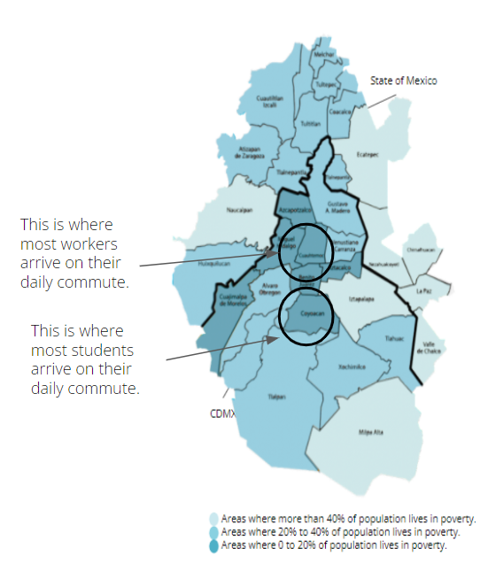

In Mexico, a way to define the difference between areas based on wealth is by identifying the percentage of each municipality's population that live in poverty.

As presented on this map, the areas where fewer people live in poverty are located in the centre and the west of CDMX, right where the city touches the State of Mexico. In addition, the areas where between 20% to 40% of the population live in poverty are in the south of the city and in some neighbourhoods of the outskirts.

This map also helps to identify that the municipalities with more population in poverty are located on the east and in the Metropolitan Area that can be considered as the “outskirts”.

Millions of people travel from these municipalities to the centre and the west, where more job opportunities are located (Cuauhtémoc delegation). While students travel mostly to municipalities located in the South (Coyoacán delegation). This could be explained by the fact that the biggest public university of the Metropolitan Area is located there.

This information is based on the [2020 Census presented by INEGI](https://www.inegi.org.mx/contenidos/programas/ccpv/2020/doc/Censo2020_Resultados_complementarios_EUM.pdf) and the [National Council of Public Policies Evaluation (CONEVAL)](https://www.coneval.org.mx/coordinacion/entidades/DistritoFederal/Paginas/pob_municipal.aspx).

Number of population in poverty per municipality

| **Municipalities with the highest number of population in poverty** | | |
| --- | --- | --- |
| **Municipality** | | **% of the population** |
| Milpa Alta | | 48.6% |
| Tlahuac | | 38.5% |
| Iztapalapa | | 37.4% |
| Álvaro Obregón | | 31.3% |
| Gustavo A. Madero | | 30.7% |
| **Municipalities with the lowest number of population in poverty** | | |
| Benito Juárez | 48.6% | |
| Miguel Hidalgo | 14.3% | |
| Cuajimalpa de Morelos | 19.7% | |
| Coyoacán | 20% | |
| Azcapotzalco | 20.6% | |

Source: CONEVAL (2010).

Use of public transport in the Metropolitan Area

About 15 million people move daily within the limits of the Metropolitan Area, whether they do it through public transport, private cars or both. According to the Origin-Destination Survey (EOD) ran by INEGI, about 51% of the population in the Metropolitan Area uses public transport (essentially the informal above the 76%, followed by the Metro with 30%), although a high percentage of users use two forms of transport buses to reach their destination (more than 65%) ([INEGI, 2017](https://www.google.com/url?sa=t&rct=j&q=&esrc=s&source=web&cd=&cad=rja&uact=8&ved=2ahUKEwiBhuaXqvv2AhU0D0QIHYWSCuA4ChAWegQIAhAB&url=https%3A%2F%2Fquivera.uaemex.mx%2Farticle%2Fdownload%2F12963%2F11514%2F&usg=AOvVaw1mhzS9Js3iR5WxWQpkMRt7)).

In addition, it is important to note that only 22% of the population in the Metropolitan Area make use of private transport like motorbikes and vehicles. This makes sense when comparing the percentage of population per socioeconómic level. From the information above, we noticed that people from levels A/B and C+ (those who own at least one car) represent 20.2% of the total population of the area. In that sense, also a percentage of inhabitants on the level C may use a private car more often than considering public transport.

* According to [INEGI](https://www.inegi.org.mx/contenidos/programas/enigh/nc/2020/doc/enigh2020_ns_presentacion_resultados_cdmx.pdf), households in CDMX spent an average of MXN $1,225 (61 USD) per trimester on public transport in 2020. This number is much lower than in 2018, when the expense was MXN $2,513 (126 USD) (a variation of 51.3%).
* According to [INEGI](https://www.inegi.org.mx/contenidos/programas/enigh/nc/2020/doc/enigh2020_ns_presentacion_resultados_mex.pdf), households in the State of Mexico spent an average of MXN $1,742 (87 USD) per trimester on public transport in 2020. This number is also much lower than in 2018, when the expense was MXN $3,096 (155 USD) (a variation of 43.7%).
* In both cases, the decrease could be due to the COVID-19 crisis which started in 2020, as this study was published in July 2021.

Expenses on public transport per region before COVID-19

| **Area** | **Expense per trimester** | **Monthly expense on PT** | **% of Level D monthly salary** |
| --- | --- | --- | --- |
| CDMX | MXN $2,513 | MXN $837 | 10% |
| State of Mexico | MXN $3,096 | MXN $1,032 | 12% |

Source: Castañeda-Olvera (2020).

The expense for transportation among the inhabitants of CDMX is a little lower, since part of the public transport is subsidised by the city government and there is a greater regulation of transportation companies. This doesn’t happen in the State of Mexico, therefore the prices can be much higher in this region.

If the average income of PT users on socioeconomic level D (our probable main target) is MXN $8,900, this means that they use the 10% of their salary in mobility for the case of the CDMX, while this represents almost the 12% of their monthly salary. The numbers can be higher if more than one person from the household needs to travel on a daily basis to several destinations.

According to [Castañeda-Olvera (2020)](https://www.google.com/url?sa=t&rct=j&q=&esrc=s&source=web&cd=&cad=rja&uact=8&ved=2ahUKEwiBhuaXqvv2AhU0D0QIHYWSCuA4ChAWegQIAhAB&url=https%3A%2F%2Fquivera.uaemex.mx%2Farticle%2Fdownload%2F12963%2F11514%2F&usg=AOvVaw1mhzS9Js3iR5WxWQpkMRt7), those who experience more inequality on their daily journeys are the inhabitants that live on the outskirts of the city, as they are the ones who not only make use of the most expensive fares of PT in the Metropolitan Area, but also earn 5% less than the households from CDMX.

In addition to this, the people from the State of Mexico are the ones that need to travel and make use of PT at a higher level than people located in the city. This is mostly because people come from the outskirts to the centre where most job opportunities and studying centres are located.

Average of journeys in the Metropolitan Area per municipality

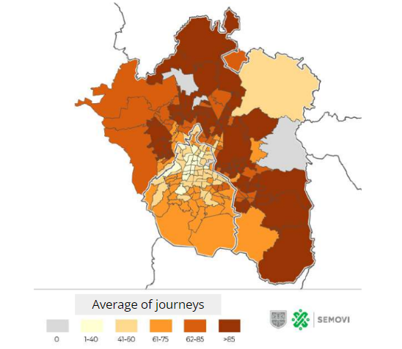

Source: Secretaría de Movilidad (SEMOVI) (2020).

As a consequence, people from the outskirts and also from the south of the city are more likely to travel to the more centric area to go to work. Particularly, inhabitants who live on the line between CDMX and the State of Mexico seem to make more use of PT, spend more money on travelling and are likely to earn 5% less than the population in the city.

According to the 2020 Census by INEGI, CDMX is the area where more people need to leave their location to study and work. On the one hand, Coyoacán is the delegation that receives more students from other sections of the Metropolitan Area. On the other hand, Cuauhtémoc receives the largest number of workers who do not live in that delegation and come from different parts of the metropolitan area or other states.

In addition to this, it is important to mention that those who make more use of PT are the ones that belong to levels C-, D+ and D, as they do not own a car but need to travel to go to work or school. The lowest socioeconomic status (level E) represents a percentage of the population with the most limited mobility, due to the lack of resources or infrastructure in their surroundings to travel far away from their origin point. According to a study presented by the [National Autonomous University of Mexico (2015)](https://www.researchgate.net/publication/283934421_Entre_mi_casa_y_mi_destino_Movilidad_y_transporte_en_Mexico) around mobility: “The most vulnerable groups are the ones with the most limited mobility and for whom transportation costs imply a higher percentage of your income”.

The following table shows how probable it is in Mexico that people would travel by any mode of transport according to their monthly earnings (this survey includes those who also travelled with private vehicles).

Percentage of people that travel and don’t travel based on their monthly income

| **Income bracket** | **% people that travel** | **% people that don’t travel** |
| --- | --- | --- |
| MXN $5,000 (minimum wage) or less | 75.42% | 24.58% |
| MXN $5,000 to MXN $10,000 | 84.50% | 15.50% |
| MXN $10,000 to MXN $15,000 | 85.71% | 14.29% |
| MXN $15,000 to MXN $25,000 | 85.36% | 14.64% |
| More to MXN MXN $25,000 | 81% | 19% |

Source: UNAM (2015).

Destination of people’s journeys based on their monthly income

| **Income bracket** | **Inside their suburb** | **Other suburbs of their municipality** | **To other municipalities (same state)** |
| --- | --- | --- | --- |
| MXN $5,000 (minimum wage) or less | 49.1% | 32.4% | 18.5% |
| MXN $5,000 to MXN $10,000 | 35.8% | 60.3% | 2.6% |
| MXN $10,000 to MXN $15,000 | 37.7% | 53.1% | 8.2% |
| MXN $15,000 to MXN $25,000 | 36.2% | 54.6% | 8.1% |
| More to MXN MXN $25,000 | 26.1% | 63.7% | 8.4% |

Source: UNAM (2015).

Mexico: phones market share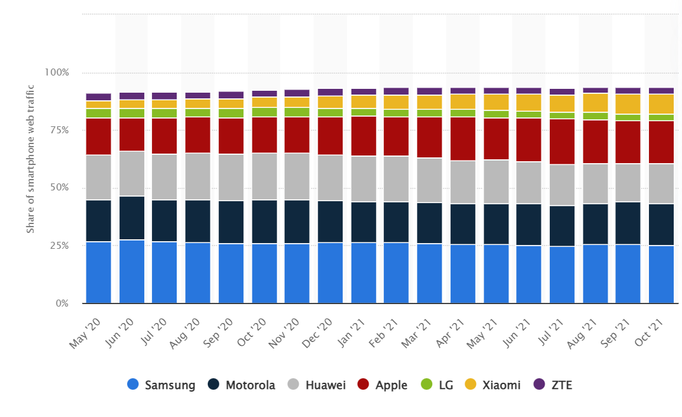

By the end of 2021, Samsung was the brand with the highest market share in Mexico, accounting for 25.1% of the smartphone web traffic. The brand has also maintained first place during the first months of 2022. Samsung ranked first in South America.

Huawei started losing market share in 2022, falling to fourth place, right after Motorola (23%) and Apple (18%). This illustrates how Apple is more relevant in Mexico than in other LATAM countries such as Lima.

In addition, it is important to note that Xiaomi is another brand that is gaining market share among the Mexican population. A similar situation was seen in the phone market share of Lima so it would be important to keep an eye on the growth of this phone brand in LATAM.

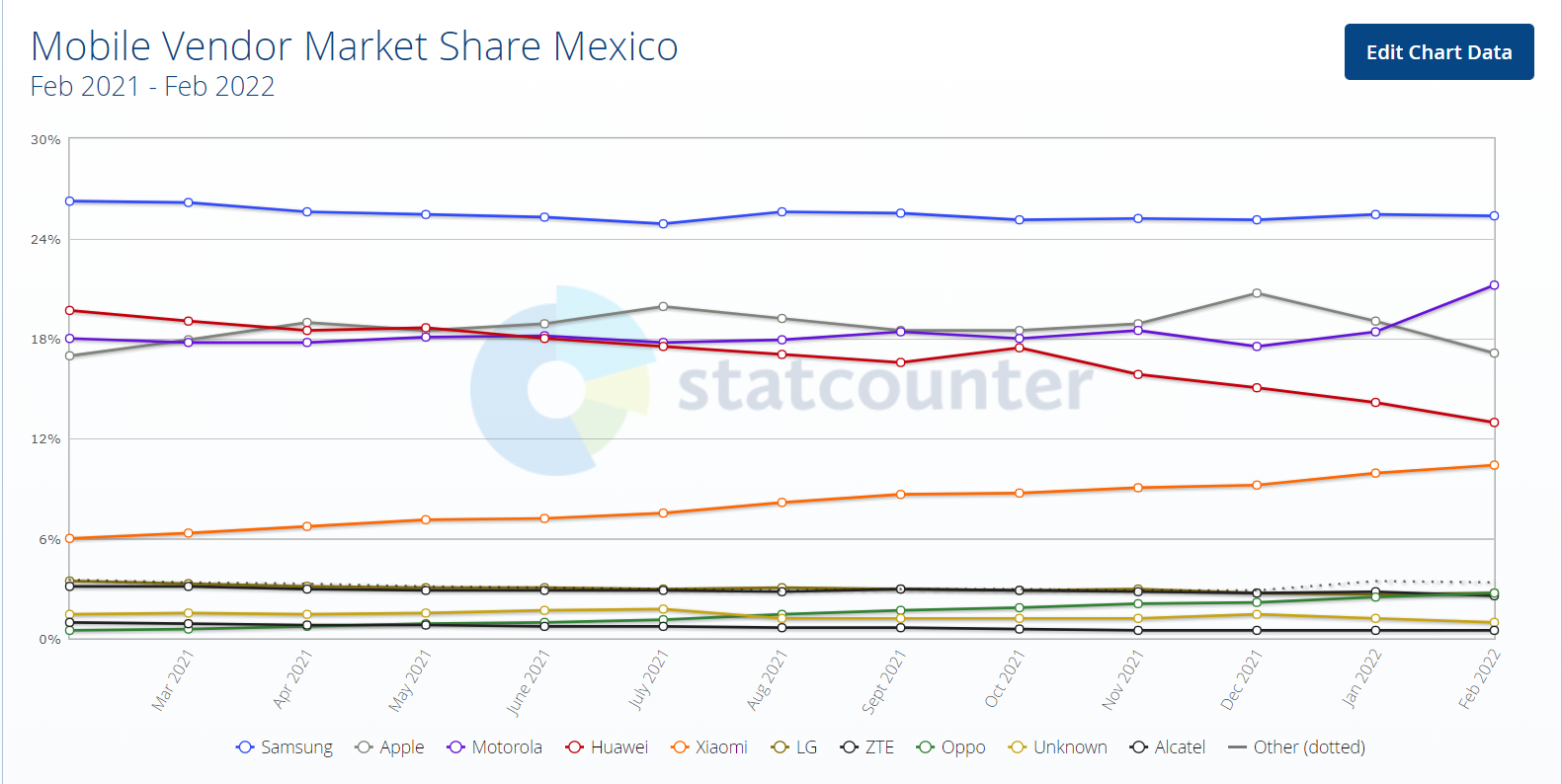

Operating systems market share in Mexico

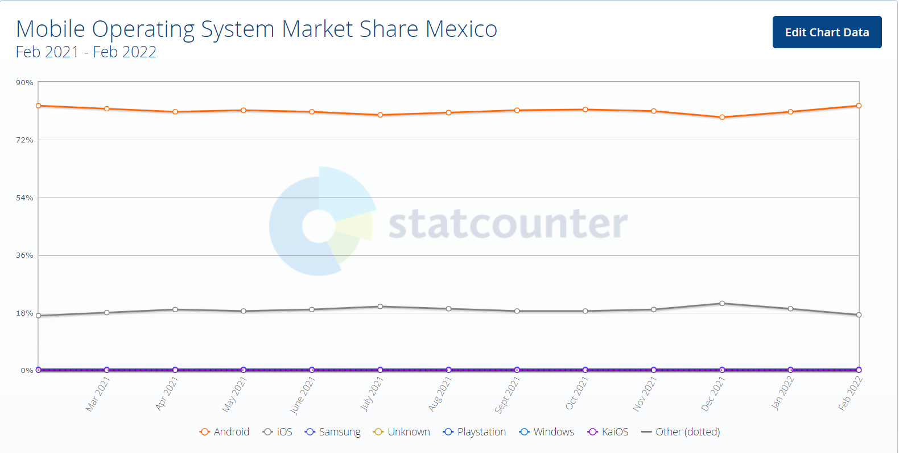

The market share of the operating system is quite related to the phone’s market share previously mentioned. In that sense, Android remains the most used operating system.

However, it is important to highlight that the iOS operating system is the second most used in Mexico, which is very different to Lima’s market share.

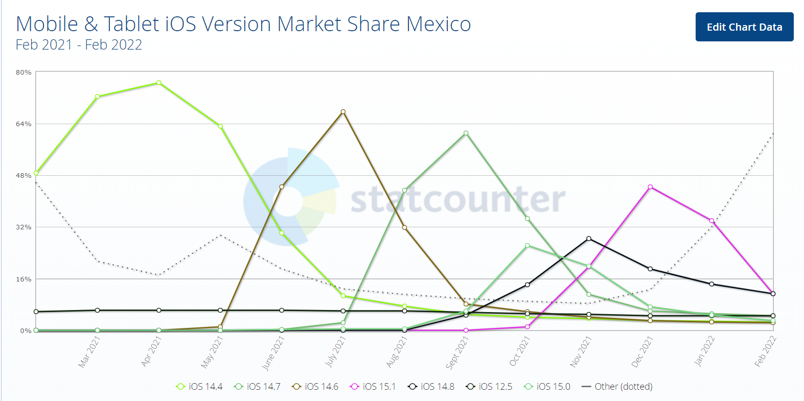

In the iOS market, the versions 15.8 and 14.1 are on the same level of use. However, it is interesting to note that the installation of the latest iOS version had its peak but is not growing anymore. This could mean that Apple users are deciding to not update their system and prefer the previous version.

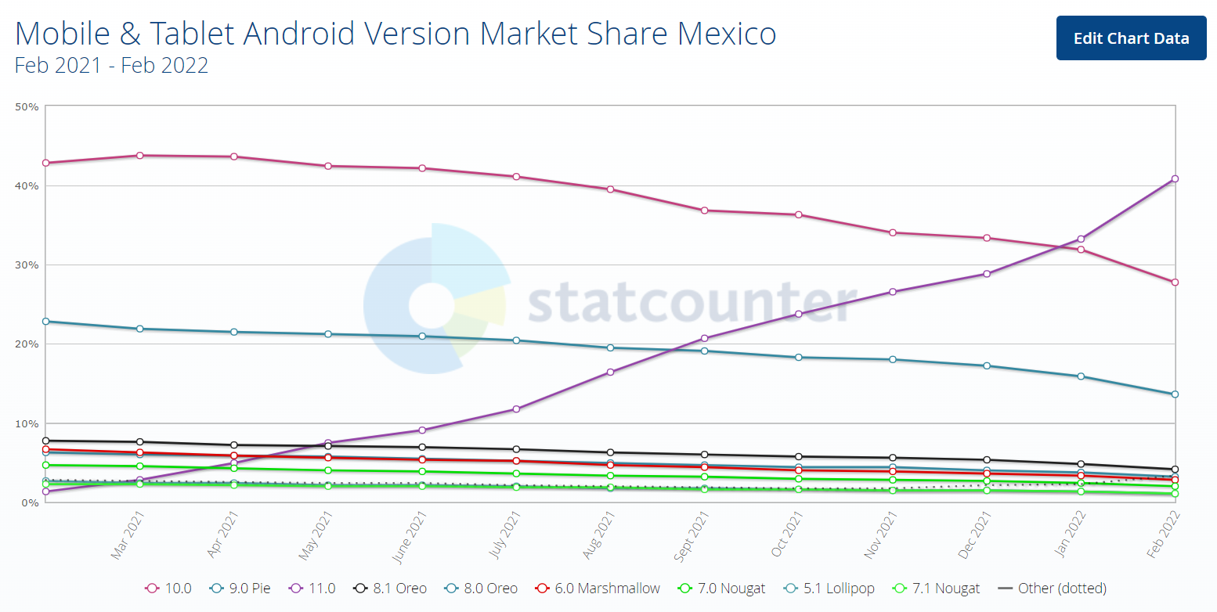

In the case of Android’s latest version, users are increasing the use of this new version, while the previous ones are losing market share. This shows that Android users are more likely to update their operating system than Apple users.

Internet use and phone use in Mexico

Taking into account the devices used to connect to the Internet, in 2018 [INEGI](https://www.inegi.org.mx/contenidos/saladeprensa/boletines/2019/OtrTemEcon/ENDUTIH_2018.pdf) announced that 92.7% of Internet users connected through a smartphone, 32.6% did it through a laptop, 32.0% used a desktop computer, 17.8% of Internet users connected through a Tablet, 16.6% through the television and 6.9% through a video game console.

According to the results of [ENDUTIH 2018](https://www.inegi.org.mx/contenidos/saladeprensa/boletines/2019/OtrTemEcon/ENDUTIH_2018.pdf), eight out of ten cell phone users have a smartphone, with which they have the ability to connect to the Internet (83.3%). In the Metropolitan Area, 85% of the population has a phone.

On the other hand, the survey indicates that in 2018 an increase in users who connect to the Internet from a smart cell phone (Smartphone) was reported, going from 92.0% in 2017 to 93.4% in 2018. This shows a difference of 5.5 million people. Connection to the Internet through data is the most used, as it represents 89% of smartphone users, while the remaining 11% is connected to the Internet only by WiFi.

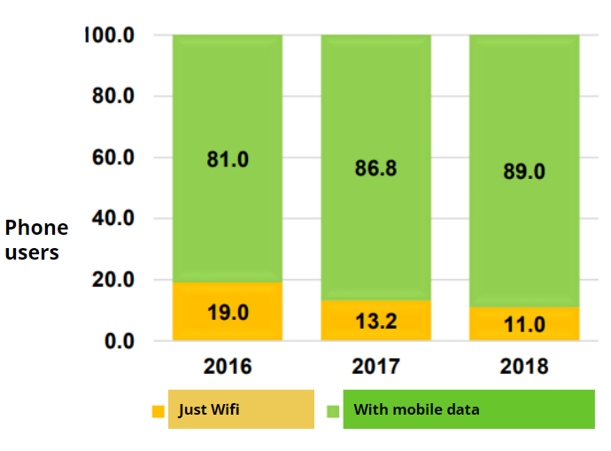

Source: INEGI (2018).

In terms of apps downloaded by Mexican phone users, 89.5% installed instant messaging, 81.2% to access social networks and 71.9% installed applications to access audio and video content. In these statistics it is relevant to highlight that 48.2% of smartphone users downloaded an app related to transit and navigation.

Free wifi in Mexico City

In 2021, Mexico City won the Guinness record as the [most connected city](https://elpais.com/mexico/2021-11-19/los-usuarios-del-internet-gratuito-de-ciudad-de-mexico-va-muy-lento-solo-lo-uso-en-caso-de-emergencia.html) in the world due to its 21,500 points with free wifi across the city. However, an article presented by the media *El País* has collected the experiences from CDMX inhabitants, which show that this connection barely works or doesn’t function at all in some areas. In addition, people are afraid of accessing this free wifi as other people have reported that their phones have been hacked or that some of their information has been stolen due to the lack of security provided by this service.

This means that having free wifi points across the city is not enough or functional enough for the users, which means that they may need to buy data or have a plan to actually be able to navigate through the internet from their phones. In the article previously mentioned, people have mentioned that the main use given to this poor wifi (when it works) is for entertainment purposes and for communications (sending messages). They don’t mention trusting on this service for activities like bank procedures nor travelling by mobility apps.

Documentation

Castañeda-Olvera (2020). Mobility and Inequality. Reflections on Mexico City. *Quivera, 22*, 85-103.

EconomíaHoy (2018). The measure of Socioeconomic Levels in Mexico has changed. *EconomíaHoy.* Available [here](https://www.eleconomista.es/consumo-eAm-mx/noticias/8893770/01/18/Cambia-el-metodo-de-medicion-de-Niveles-Socioeconomicos-en-Mexico.html).

Mexican Association of Market Intelligence Agencies and Public Opinion AC. (AMAI) (2020). Questionnaire for the Application of the AMAI 2022 Rule and Table of Classification. *AMAI.* Available [here](https://www.amai.org/descargas/CUESTIONARIO_AMAI_2022.pdf).

Mexican Association of Market Intelligence Agencies and Public Opinion AC. (AMAI) (2020). Socioeconomic Levels in Mexico 2020. *AMAI.* Available [here](https://www.amai.org/NSE/index.php?queVeo=NSE2020).

National Institute of Statistics and Geography. (2019). In Mexico, there are 74.3 million internet users and 18.3 million households with connection to this service: ENDUTIH 2018. *INEGI.* Available [here](https://www.inegi.org.mx/contenidos/saladeprensa/boletines/2019/OtrTemEcon/ENDUTIH_2018.pdf).

National Institute of Statistics and Geography. (2020a). National Income Survey and Expenses of Households 2020. *INEGI.* Available [here](https://www.inegi.org.mx/contenidos/programas/enigh/nc/2020/doc/enigh2020_ns_presentacion_resultados_cdmx.pdf).

National Institute of Statistics and Geography. (2020b). Population and Households Census 2020. *INEGI*. Available [here](https://www.inegi.org.mx/contenidos/programas/ccpv/2020/doc/Censo2020_Resultados_complementarios_EUM.pdf).

National Council of Public Policies Evaluation (CONEVAL). (2010). Percentage of Poor Population in CDMX. *CONEVAL*. Available [here](https://www.coneval.org.mx/coordinacion/entidades/DistritoFederal/Paginas/pob_municipal.aspx).

National Autonomous University of Mexico (UNAM). (2015). Between my home and my destiny. Mobility and transportation in Mexico. México: UNAM. Available [here](https://www.researchgate.net/publication/283934421_Entre_mi_casa_y_mi_destino_Movilidad_y_transporte_en_Mexico).

Rumbo (2021). *Rumbis on Rumbo 2021 Report*. Available [here](https://docs.google.com/presentation/d/1Ztw38KwUnZ5SGDuRYMjFQGj53Pm3Yskb1QNZYorIBcE/edit?usp=sharing).

Santos, A. (2021). CDMX free internet users: “It is very slow, I just use it in case of emergency”. *El País.* Available [here](https://elpais.com/mexico/2021-11-19/los-usuarios-del-internet-gratuito-de-ciudad-de-mexico-va-muy-lento-solo-lo-uso-en-caso-de-emergencia.html).

Secretaría de Movilidad (SEMOVI) (2020). Integral Programme of Mobility of CDMX (2020-2024). *SEMOVI.* Available [here](https://semovi.cdmx.gob.mx/storage/app/media/diagnostico-tecnico-de-movilidad-pim.pdf).

Statcounter (2022). *Mobile Operating System Market Share Mexico*. Available [here](https://gs.statcounter.com/os-market-share/mobile/mexico).

Statcounter (2022). *Mobile Vendor Market Share Mexico*. Available [here](https://gs.statcounter.com/vendor-market-share/mobile/mexico).

Numbers in USD

Income brackets among the working population

| **Income brackets among the working population (monthly)**  **USD** | **Number of inhabitants in Mexico** | **Population in Mexico** |
| --- | --- | --- |
| 250 (minimum wage) or less | 13,531,437 | 24% |
| 250 to 500 | 19,597,015 | 34.7% |
| 500 to 750 | 7,697,724 | 13.6% |
| 750 to 1250 | 3,659,517 | 6.5% |
| More to 1250 | 1,353,543 | 2.4% |
| No income perceived | 3,316,971 | 5.9% |
| Didn’t specify | 7,331,278 | 13% |
| Total of working population in Mexico: | 56,487,485 | 100% |

Source: INEGI (2021).

Socioeconomic levels in the Valley of Mexico

| **Level** | **Average monthly income per household USD** | **% of Valley of Mexico population** | **Number of inhabitants** |
| --- | --- | --- | --- |
| Level A/B | More than $1,700 | 7.6% | 1,657,143.216 |
| Level C+ | $1,200 to $1,700 | 12.6% | 2,747,369.016 |
| Level C | $900 to $1,200 | 15% | 3,270,677.4 |
| Level C- | $700 to $900 | 18.3% | 3,990,226.428 |
| Level D+ | $500 to $700 | 16.4% | 3,575,940.624 |
| Level D | $300 to $500 | 23% | 5,015,038.68 |
| Level E | Less than $300 | 7% | 1,526,316.12 |

*Sources: AMAI (2020).

Expenses on public transport per region before COVID-19

| **Area** | **Expense per trimester USD** | **Monthly expense on PT USD** | **% of Level D monthly salary** |
| --- | --- | --- | --- |
| CDMX | USD $126 | USD $42 | 10% |
| State of Mexico | USD $155 | USD $51 | 12% |

Source: Castañeda-Olvera (2020).